**Unit 7: Introduction to Enterprise Architecture**

**What is an enterprise architecture (EA)?**

An enterprise architecture (EA) is a conceptual blueprint that defines the structure and operation of organizations. The intent of enterprise architecture is to determine how an organization can effectively achieve its current and future objectives. Enterprise architecture involves the practice of analyzing, planning, designing and eventual implementing of analysis on an enterprise.

### 2. The importance of enterprise architecture

Enterprise architecture will help multiple departments in a business understand the broader business model and articulate challenges and business risks. Because of this, enterprise architecture has an important role in unifying and coordinating departmental processes across an organization. Being able to access and understand business capability should also help individuals identify [gaps](https://www.techtarget.com/searchcio/definition/gap-analysis) in their business, and from there, they can make more informed decisions.

The definitions of EA emphasize EA as a framework and EA as a process for transforming an enterprise. The increasing pace of information technology has influenced the increased need for Enterprise Architecture. Adopting EA is the key to the survival of an enterprise due to the high rates of change and complexity in the world economy.

An enterprise that aspires to achieve its vision must be able to identify. Its current or as-it state and have a concrete plan on how to get to its target or to-be state. Without an appropriate communication method and tools, it can be challenging to communicate the vision of the enterprise.

However, EA depicts an enterprise’s current state and aspired future state with visual models making communication much easier and faster. Enterprise Architecture plays an important role in an organization. It is critical to the survival and success of the organization while enabling the organization to achieve the right balance between IT efficiency and business innovation.

Typically, EA helps to facilitate business success such as competitive advantage through the effective use of [information management strategies](https://www.ilearnlot.com/characteristics-of-management-information-systems-mis/54779/) and IT resources. Enterprise Architecture can use by a company to organize and structure. Its enterprise infrastructure providing stakeholders and system architects with appropriate architectural details.

Enterprise Architecture may, however, develop for a wide variety of reasons. EA develops for:

##### **Alignment:**

To ensure that the implemented enterprise aligns with management’s intent.

##### **Integration:**

The connectivity and interoperability of business rules, processes, information flow, and interfaces are consistent across the organization.

##### **Convergence:**

Pushing towards a standardized IT portfolio based on the Technical Reference Model (TRM). Thus, creating a common organizational language.

##### **Change:**

Facilitating and managing improvement in all aspects of the enterprise.

Another important reason to consider EA adoption is the need for an organization to stay committed to its long-term goals. The agility of an enterprise is dependent on a long-term implementation strategy using EA while short-term implementation creates a temporary illusion of an agile enterprise.

Therefore, EA is a mechanism to help her adopters remain focused on the achievement of long-term visions while providing a framework for managing everyday operational risks. To respond to the constant changes in business needs, a stable platform is needed to support enterprise operations.

The traditional approach to building an [information system](https://www.ilearnlot.com/management-information-system-mis/54675/), by purchasing applications specifically for a department or a unit area; increases complexity, introduces redundancy, and hinders the enterprise from growing. This knows as business silos. It is whereby individually the application functions effectively but when combine gives no foundation for execution of enterprise processes.

However, the introduction of EA into an enterprise process is a holistic approach taken to address the organization-wide application needs. With, a clear understanding of how each component relates to others both at the data, software, and hardware levels of abstraction resulting in integrated silos architecture.

### The purpose of enterprise architecture

The main goals of enterprise architecture may be to create a map or blueprint of the structure and operations of an organization. This blueprint should include information such as a map of IT assets and [business processes](https://www.techtarget.com/searchcio/definition/business-process).

Other common goals include promoting team alignment and standardization. This can be done in part by unifying environments across teams and organizations. Guidance is normally based on an organization's business requirements.

### Enterprise architecture models and methodologies

Enterprise architectures are typically implemented as frameworks. There are many different frameworks, and some will be a better fit than others when it comes to any one organization. For example, a framework focused on consistency and relationships between various parts of an overarching enterprise will be more helpful to larger organizations with many moving parts compared to small ones. In this case, a framework like the Unified Architecture Framework (UAF) may work.

Some example frameworks include:

* The Zachman Framework for Enterprise Architecture -- which covers six architectural points as well as six primary stakeholders that aid in defining and standardizing IT architecture components.
* Unified Architecture Framework (UAF) -- which is a complex but flexible enterprise architecture framework suitable for military and government software development as well as use in commercial businesses. It's implemented as a [UML profile](https://www.techtarget.com/searchsoftwarequality/definition/Unified-Modeling-Language).
* Agile enterprise architecture -- which focuses an organization around a flexible, extended collection of structures and processes that can grow. It can become an important part of [Agile software delivery](https://www.techtarget.com/searchsoftwarequality/definition/agile-software-development).
* Federal Enterprise Architecture Framework (FEAF) – which is a reference model that was introduced in 1996 for IT effectiveness. It was designed for the U.S. government but can be used in private companies as well.

Other frameworks include [The Open Group Architectural Framework](https://www.techtarget.com/searchapparchitecture/definition/The-Open-Group-Architecture-Framework-TOGAF), the European Space Agency Architectural Framework, the SAP Enterprise Architecture Framework or the Ministry of Defence Architecture Framework.

### Benefits of enterprise architecture

Possible advantages of having an enterprise architecture include:

* Improved decision-making;
* Improved adaptability to changing demands or market conditions;
* Elimination of inefficient and redundant processes;
* Optimization of the use of organizational assets;
* Minimization of employee turnover;
* Support organization changes for redesigns and reorganization;
* Makes it easier to evaluate architecture against long-term goals;
* Can give views of IT architectures to those outside of IT;
* Can help with the unification of processes in IT;
* Can help simplify finance teams; and
* Facilitates collaboration with [project management](https://www.techtarget.com/searchcio/definition/project-management).
* It provides a clear model of the organization’s business, application, data and technology architecture, dependencies, and inter-relatedness. This will help the organization to make business decisions based on a holistic view instead of as a stand-alone part.
* Enterprises can increase their business values by aligning IT with their business strategy; it helps the organization to unlock the power of information, unifying information silos that inhibit business processes.
* EA ensures organizations invest in projects that are targeted towards their goals, objectives, and visions. It identifies opportunities for reuse and integration which prevents inconsistent processes and information.
* It provides an organization with a planning process to better understand its business strategy; which helps the organization to respond faster to competitive pressures and deploy a higher quality faster.
* EA identifies duplicate and overlapping processes, services, data hardware, and software, traces high-cost areas of IT assets to develop a fairer cost model, and ensures compliance with legal and regulatory laws.

**3. Enterprise architecture models.**

Definition: **A compendium of the highest level of data and process models** is an enterprise architecture model. This is a model that captures high-level business entities (BECs) and high-level business processes (BASs) that reflect the major reasons for the enterprise's (corporation's) existence.

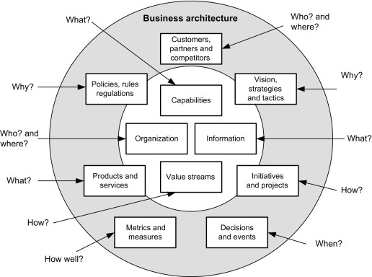

## How Does an Enterprise Architecture Model Work?

In the end, the frameworks outlined in an Enterprise Architecture model help the business connect with customers and partners by enabling all interactions and transactions. These interactions are being driven by the systems that make up an enterprise's architectural components. People might see them as decision-making tools and services, information assets, communication routes, and workflows. In order for individuals to connect with the company, they assume solid shape in both real and virtual settings, including private discussions, phone calls, or web-based transactions.

Enterprise Architecture projects need to be conscious of this function and create architectures that provide actual benefit to people in accessible systems rather than being viewed as a purely background operation. By creating processes that are tailored to the demands of consumers, workers, and other stakeholders, they should implement the strategic goal in a methodical way. They should provide tangible designs that people can see and use.

Applying the architecture perspective makes it easier to understand how an enterprise structure affects a design and how it incorporates architectural decisions and principles to be a part of that structure. Every design includes architecture as a fundamental element that shapes the company as a whole and greatly affects how it functions and the experiences people have with it.

## What Makes a Good Enterprise Architecture Model?

A good Enterprise Architecture model helps you understand how your organization works, and the source of a deficiency you would like to correct. A great Enterprise Architecture model lets you exercise change and see the impact of change.

Let’s consider an analogy to better illustrate our point. A budget spreadsheet will break your spending down to rent, power, heat, investments, etc. Then, if you wanted to increase spending on other things, such as a house, you can see what options your have in your spreadsheet. Enterprise architects do the same thing to look at things like changing digital customer engagement, integrating an acquisition, or upgrading major enterprise software. Really poor models are often static, as they simply “show” something. Bad models don’t let you see impact of possibility, while good models do. Really strong models let you focus the purpose of change on stakeholder for decision-maker concerns like [agility](https://conexiam.com/what-is-enterprise-agility/) or other [standard EA use cases](https://conexiam.com/enterprise-architecture-use-cases/).

## What is the Core Purpose of Enterprise Architecture?

The purpose of Enterprise Architecture is to establish a unified IT environment across the company or among all of the company's business units, with strong symbiotic ties to the business side of the organization (which, as was previously mentioned, typically accounts for 90% of the company, at least in terms of budget). The objectives are more precisely to encourage alignment, standardization, reuse of current IT assets, and the dissemination of standard project management and software development processes throughout the business. The corporate design should ultimately result in cheaper, more strategic, and more responsive IT.

The goal of Enterprise Architecture is to develop a diagram of IT resources, business processes, and a set of governance guidelines that will serve as the foundation for continuous discussions about business strategy and how it may be implemented through IT. We'll discuss a variety of proposed frameworks for creating an Enterprise Architecture later on in this tutorial.

## Why Should Enterprise Architecture Models Be Used?

The organization's people, business procedures, information, and technology, as well as the connections between them and with the surrounding environment, are all included in the scope of Enterprise Architecture. Business, information, process, and technology architectural domains are aligned inside businesses using Enterprise Architecture, which uses architecture concepts and methods. These require utilizing multiple enterprise components, such as business and technology alignment, consistency in a federated environment, interoperability and information sharing, return on investment, flexibility, and agility, to identify, drive, and realize these improvements.

There are other use cases, as well. In the past, Enterprise Architectures produced lengthy multi-year plans with a lot of analysis, a slow pace, and rigid conceptual frameworks. These outdated Enterprise Architecture mindsets have been rendered obsolete by the agility and DevOps trend in today's IT management best practices.

The supporting technologies for Enterprise Architecture have developed along with the discipline. Scalable, supporting complicated modeling, corporate collaboration, useful connectors, simplicity of use, and improving data integrity and quality are all features of specialized Enterprise Architecture-focused technologies. A wide range of use cases, including cloud transformation, data compliance, standards governance, integration architecture, and others, are covered by professional Enterprise Architecture Model tools.

**4. Zach man Framework**

# What is Zachman Framework?

Enterprise Architecture (EA) is a discipline which has evolved to structure the business and its alignment with the IT systems. The **[Zachman Framework](https://www.visual-paradigm.com/features/zachman-framework-tools/)** is an enterprise ontology and is a fundamental structure for Enterprise Architecture which provides a way of viewing an enterprise and its information systems from different perspectives, and showing how the components of the enterprise are related.

“Enterprise Architecture is the process used by a business to make explicit representations of enterprise operations and resources, rather than relying on implicit notions or understanding in individual managers' heads.”

--Stan Locke

## **Why Zachman Framework?**

In today's complex business environments, many large organizations have great difficulty responding to changes. Part of this difficulty is due to a lack of internal understanding of the complex structure and components in different areas of the organization, where legacy information about the business is locked away in the minds of specific employees or business units, without being made explicit.

The Zachman framework provides a means of classifying an organization's architecture. It is a proactive business tool, which can be used to model an organization's existing functions, elements and processes - and help manage business change. The framework draws on Zachman's experience of how change is managed in complex products such as airplanes and buildings.

## **Structure of Zachman Framework**

Zachman Framework is a two dimensional classification scheme for descriptive representations of an Enterprise that is structured as a matrix containing 36 cells, each of them focusing on one dimension or perspective of the enterprise. Rows are often presented as different viewpoints involved in the systems development process, while columns represent different perspectives of the stakeholders involved in the organization.

The rows of Zachman Framework focus on describing the enterprise from six viewpoint perspectives of the stakeholders. These six perspectives are based on English language interrogatives 'what', 'where', 'who', 'when', 'why', and 'how' (known as W5H).

The columns of the framework consist of a set of artifacts which are description of the enterprise from specific viewpoint of a group of stakeholders. The stakeholders are generally grouped as planners, owners, designers (architects), implementers, sub-constructors, users, or sometimes represented as viewpoints: scope context, business concepts, system logic, technology, physics, component assembles and operations classes.

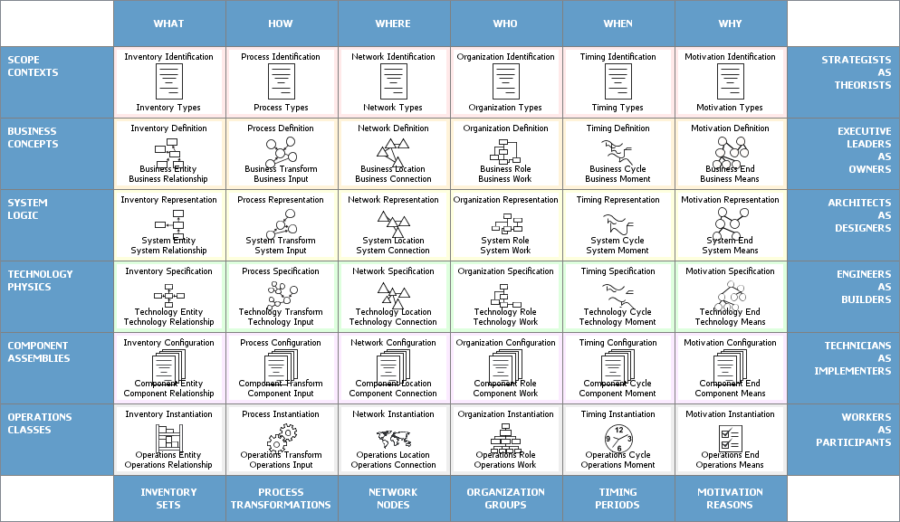

The framework enables complex subjects to be distilled into systematic categories in the column headers, using these six basic questions (known as 5WH). The answers to these questions will differ, depending on the perspective or audience (represented in the rows).

Each view is a description from a particular perspective and has a representation (a model or functioning system), as indicated in the Table above. Here is a brief description of each view and model/functioning system:

### Columns of Zachman Framework

The columns represent the interrogatives or questions that are asked of the enterprise. These are:

* **What** (data) - what is the business data, information or objects?
* **How** (function) - how does the business work, i.e., what are the business' processes?
* **Where** (network) - where are the businesses operations?
* **Who** (people) - who are the people that run the business, what are the business units and their hierarchy?
* **When** (time) - when are the business processes performed, i.e., what are the business schedules and workflows?
* **Why** (motivation) - why is the solution the one chosen? How was that derived from? What motivates the performance of certain activities?

### Rows of Zachman Framework

Each row represents a distinct view of the organisation, from the perspective of different stakeholders. These are ordered in a desired priority sequence. A row is allocated to each of the following stakeholders:

* **Planner's View** (Scope Contexts) - This view describes the business purpose and strategy, which defines the playing field for the other views. It serves as the context within which the other views will be derived and managed.
* **Owner's View** (Business Concepts) - This is a description of the organization within which the information system must function. Analyzing this view reveals which parts of the enterprise can be automated.
* **Designer's View** (System Logic) - This view outlines how the system will satisfy the organization's information needs. The representation is free from solution specific aspects or production specific constraints.
* **Implementer's View** (Technology Physics) - This is a representation of how the system will be implemented. It makes specific solutions and technologies apparent and addresses production constraints.
* **Sub-Constructor's View** (Component Assembles) - These representations illustrate the implementation-specific details of certain system elements: parts that need further clarification before production can begin. This view is less architecturally significant than the others because it is more concerned with a part of the system than with the whole.
* **User's View** (Operations Classes) - This is a view of the functioning system in its operational environment.

## **Rules of Zachman Framework**

The framework offers a set of descriptive representations or models relevant for describing an enterprise.

* Each cell in the Zachman Framework must be aligned with the cells immediately above and below it.
* All the cells in each row also must be aligned with each other.
* Each cell is unique.
* Combining the cells in one row forms a complete description of the enterprise from that view.

**5. TOGAF Framework**

TOGAF is an enterprise architecture framework that helps define business goals and align them with architecture objectives around enterprise software development.

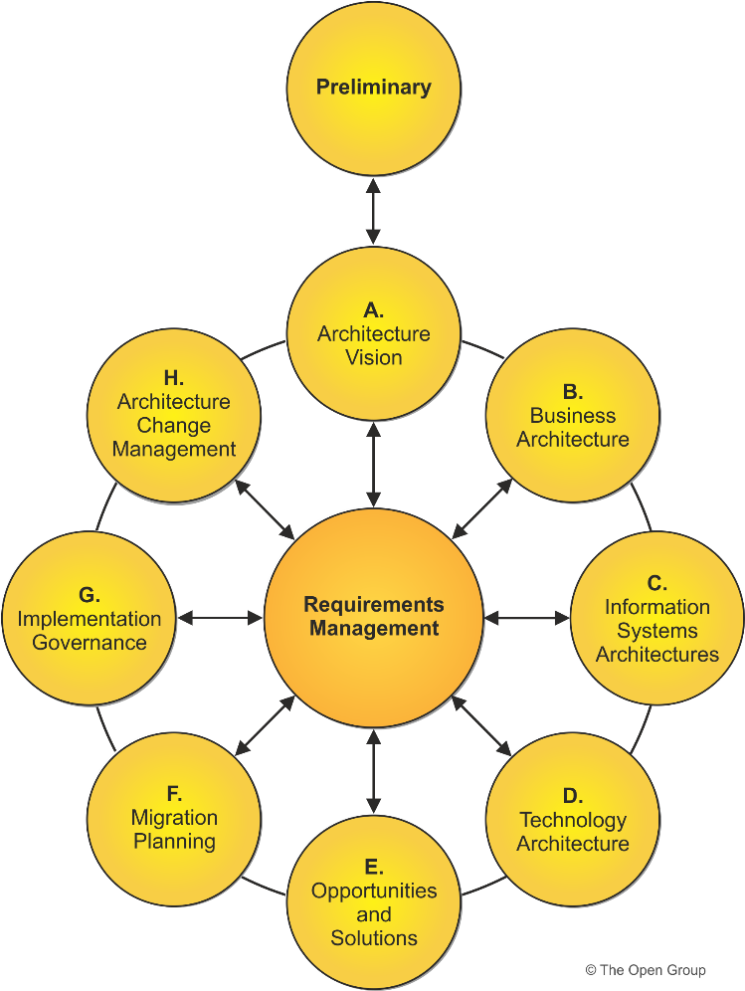

TOGAF Standards

## TOGAF definition

The Open Group Architecture Framework (TOGAF) is an [enterprise architecture](https://www.cio.com/article/222421/what-is-enterprise-architecture-a-framework-for-transformation.html) methodology that offers a high-level framework for enterprise software development. TOGAF helps organize the development process through a systematic approach aimed at reducing errors, maintaining timelines, staying on budget, and aligning IT with business units to produce quality results.

## **The TOGAF approach to EAFs**

The Open Group [defines](http://www.opengroup.org/subjectareas/enterprise/togaf) the TOGAF as the “de factor global standard for enterprise architecture”. The framework is intended to help enterprises organize and address all critical business needs through four goals:

* **Ensuring all users, from key stakeholders to team members, speak the same language.** This helps everyone understand the framework, content, and goals in the same way and gets the entire enterprise on the same page, breaking down any communication barriers.
* **Avoiding being “locked in”** to proprietary solutions for enterprise architecture. As long as the company is using the TOGAF internally and not towards commercial purposes, the framework is free.
* **Saving time and money** and utilizing resources more effectively.
* **Achieving demonstrable return on investment** (ROI).

## **3 pillars of TOGAF**

If the four goals are the theoretical outcome of using TOGAF, then the three pillars are the way to achieve the goals. These pillars help create a systematic process to organize and put software technology to use in a structured way that aligns with governance and business objectives. Because software develop relies on collaboration across various business departments inside and outside of IT, TOGAF’s goal of speaking the same language encourages and assists t he various stakeholders to get on the same page, something that may not otherwise happen in business environments.

The TOGAF is divided into [three main pillars](https://en.wikipedia.org/wiki/The_Open_Group_Architecture_Framework):

### Enterprise architecture domains

Enterprise architecture domains divide the architecture into four key areas (sometimes shortened to ‘BDAT areas’):

* **Business architecture,** which defines business strategy and organization, key business processes, and governance and standards.
* **Data architecture,** which documents the structure of logical and physical data assets and any related data management resources.
* **Applications architecture,** which provides a blueprint for deploying individual systems, including the interactions among application systems as well as their relationships to essential business processes.
* **Technical architecture** (also known as technology architecture), which describes the hardware, software, and network infrastructure necessary to support the deployment of mission-critical applications.

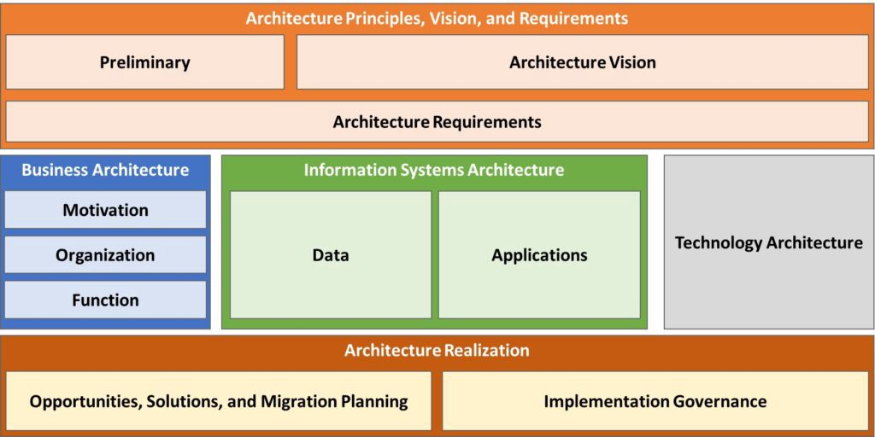

TOGAF Framework

## **The heart of TOGAF**

Proponents say that ADM is the heart of TOGAF: it’s this pillar that makes TOGAF both very effective and a standout from other frameworks. The Architecture Development Method offers eight steps as guidance to figure out where the enterprise currently is and determine where the enterprise wants and needs to be in each of the four enterprise architecture domains.

Once business processes are established through the entire lifecycle, the ADM helps the enterprise to:

1. Identify the gaps between current status and long-term goals.
2. Collate these gaps into smaller actionable and understandable packages that the team can then implement.

Two other areas are sometimes included in TOGAF’s main pillars:

* TOGAF certified tools
* Qualifications

The Open Group offers [two certifications](https://en.wikipedia.org/wiki/The_Open_Group_Architecture_Framework) for individuals:

* The first level is known as the Foundation, teaching basic tenets of enterprise architecture and rolling out TOGAF.
* Level 2 Certified involves business analysis and application.

The Open Group also certifies tools that align with TOGAF. For the most recent version, [eight tools from eight organization](https://certification.opengroup.org/register/togaf-tool) are available.

## **Benefits of using TOGAF**

The benefits of ADM are that it is customizable to organizational need—there’s no need to create a structure that doesn’t serve your business. These smaller packages are also scalable, so if one team rolls it out, it can successfully be rolled out to other teams without much tweaking. This helps the enterprise establish a process with multiple check points, so that there are few errors the wider the architecture is implemented.

There can also be benefits to individuals who certify in TOGAF. A study of industry employees indicates that [enterprise architects](https://www.bmc.com/blogs/system-architect/), software architects, and [IT directors](https://www.bmc.com/blogs/it-director-role-and-responsibilities-what-does-a-director-of-technology-do/), among others, who choose to earn a certification in TOGAF often see an average yearly pay bump of $10,000 to $20,000 over similarly placed colleagues who aren’t certified.

Some experts in enterprise architecture point out that while TOGAF may appear very logical, it’s actually quite a shake up to traditionally educated technology consultants today – but perhaps this will change has TOGAF adoption continues along steadily.